Calling all dinghy sailors. Please join us at Saratoga Sailing Club for the Scow Moth & Lowrider 2025 National Championships. Regardless of your design type, historic, classic or modern vintage all non-foiling boats are welcome. Perhaps you have a boat hanging up in your garage or know of a friend who does, please join us on Sundays for club racing in preparation for the National Championships 6th- 11th of January 2025. Perhaps you would like to sail in this class and do not have a boat, used and new boats are available. Go to these sites, send us a message and we will get you started. Sail a Moth, preserve sailing history and join in on the fun.

<https://www.facebook.com/groups/700982496682772> OR <https://www.moth.asn.au/Lowriders>

Race Start, Lake Cootharaba, QLD National Championships 2024.

Historical scow moth 1960’s ( No wings, restored )

Classic Moth 1976 ( with wings, restored )

Modern Skiff moth, lowrider 1980’s Modern Skiff moth , lowrider 1990’s

( with wings, original ) ( with wings, original )

Build your own scow moth. Splinter and Imperium designs kits available

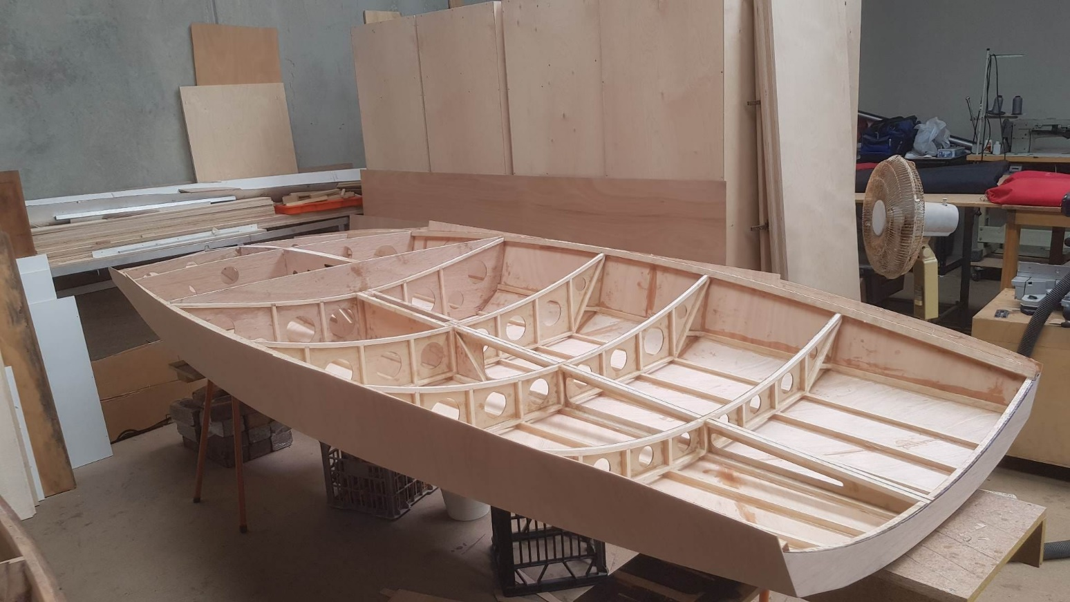

Build your own Skiff moth. Tortured ply, home built and designed. National champion 2023

